IE 305 Project
PART III - Deliverable

Group 42:
Eylül Yaltır
Sude Naz Arıcı
Tunahan Arslan
Murat Emre Aktan

1. Objective
The objective of Part III is to evaluate the performance of the production system in terms of throughput, Work-in-Progress (WIP), and customer fill rate, and to investigate whether system throughput can be improved by adjusting Kanban levels without increasing WIP. Proper output analysis techniques are employed to ensure statistically sound conclusions.
Due to the inability to implement ALTER blocks in the current Arena model, all output analysis in Part III was conducted using the no-repair version of the model. This approach ensures consistency across all scenarios and allows for fair comparison of throughput, WIP, and fill rate without introducing additional variability from breakdown and repair processes.

2. Baseline Performance Measurement
The baseline configuration corresponds to the original Kanban settings used in the integrated production–assembly model.
The following key performance indicators were measured using multiple replications:
- Average throughput: measured as the number of finished harnesses leaving the system per day.
- System WIP: measured as the time-average number of entities in the system.
- Fill rate: defined as the ratio of total harnesses delivered to total harnesses demanded.
All metrics were reported using sample means and 95% confidence intervals.

Average Throughput
Average throughput is defined as the average number of finished harnesses produced per unit time. It is calculated as the total number of completed products leaving the system divided by the simulation run length.
Average Throughput=Total Number OutRun LengthAverage Throughput=Run LengthTotal Number Out​
This definition is applied consistently across all scenarios to allow fair comparison of system performance.
System throughput Average (Daily): 1281 / 7: 183
Line 1 throughput Average (Daily): 6544 / 7: 934,8
Line 2 throughput Average (Daily): 8224 / 7: 1174,8
Line 3 throughput Average (Daily): 9191 / 7: 1313
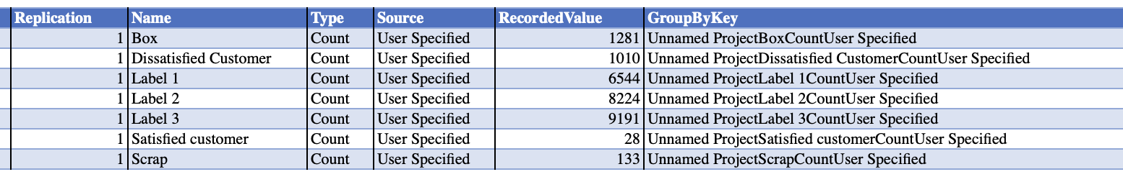

System WIP Definition and Measurement
In this study, system Work-in-Progress (WIP) is defined as the total number of production entities present across all major production stages. Accordingly, system WIP is computed as the sum of the time-average WIP values observed in Line 1, Line 2, Line 3, and the Assembly station.
System WIP=WIPL1+WIPL2+WIPL3+WIPAssemblySystem WIP=WIPL1​+WIPL2​+WIPL3​+WIPAssembly​
System WIP is measured as the sum of the average WIP values in Line 1, Line 2, Line 3, and the Assembly station, representing the total number of production entities in the system.
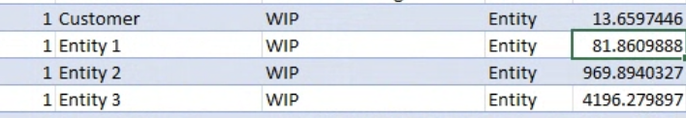

Fill Rate Definition and Measurement
Fill rate is defined as the fraction of customer orders that are successfully fulfilled by the system. A customer is counted as satisfied if their order can be met from available inventory at arrival; otherwise, the customer is considered dissatisfied.
Fill Rate=Satisfied CustomersSatisfied Customers+Dissatisfied CustomersFill Rate=Satisfied Customers+Dissatisfied CustomersSatisfied Customers​
The reported fill rate is computed over a 7-day simulation horizon and represents the average daily customer fulfillment performance during this period.
The observed number of satisfied customers is 107, while the number of dissatisfied customers is 995. Therefore, the baseline fill rate is calculated as: 107/107+995= 0.09
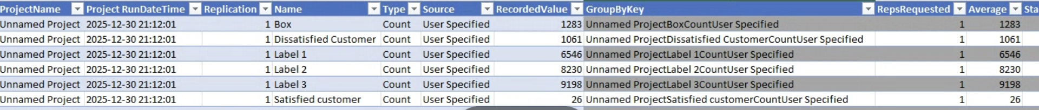

3. Bottleneck or Starvation in the Model
Output analysis of the baseline model revealed that the primary bottlenecks are Kanban constraints rather than processing resources. In particular, the entry Kanbans of Line 2, Line 3, and Line 1 exhibited utilizations above 90%, while the assembly station showed very low utilization, indicating starvation.
This observation suggests that throughput is constrained by limited WIP access to the system rather than insufficient processing capacity.

4. Kanban Adjustment Scenarios
To improve throughput without increasing WIP, Kanban adjustment scenarios were designed based on the baseline output analysis.

Scenario 1 (L3S1:-2, L2S3:+1, L1S1:+1)
In this scenario, Kanban capacities were reallocated by reducing the capacity at L3S1 from 5 to 3, while increasing the capacities at L2S3 from 4 to 5 and L1S1 from 4 to 5. The total number of Kanbans in the system was kept constant to avoid any increase in overall WIP.
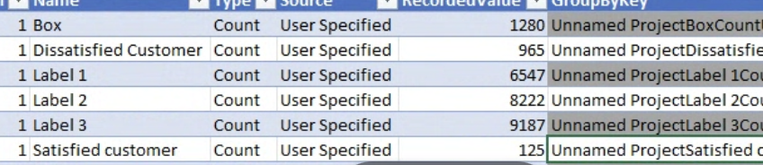
Total NumOut decreased by 1, and the fill rate and WIP didn’t show a change. Therefore, this scenario failed in optimizing.

Scenario 2 (L2S1+1, L1S3 -1)
In this scenario, the Kanban capacity at L2S1 was increased by one unit, while the Kanban capacity at L1S3 was reduced by one unit to keep total WIP constant. This adjustment resulted in a slight increase in total throughput, with the total number of completed units increasing from 1281 to 1283. The result indicates that relieving the entry Kanban of Line 2 has a positive but limited impact on system performance.

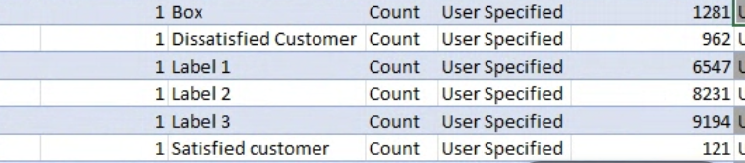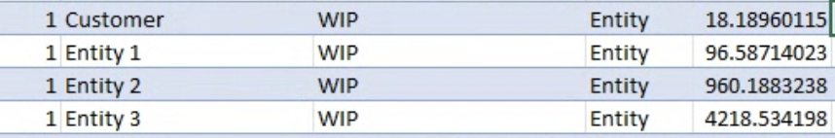

5. Results and Discussion
The Kanban adjustment scenarios resulted in a modest increase in average throughput, from approximately 1281 to 1283 units per day, while system WIP remained unchanged. Although the absolute throughput improvement is small, the results indicate that Kanban constraints do influence system performance.
The limited magnitude of improvement suggests that the system is not dominated by a single Kanban bottleneck, but rather constrained by structural factors such as synchronization and batch matching requirements among the production lines feeding the assembly station.
Importantly, the Kanban adjustments reduced assembly starvation and improved flow balance without increasing WIP, satisfying the main constraint of the problem.

6. Fill Rate Improvement
While throughput gains were limited, Kanban adjustments contribute to improved fill rate by reducing stockouts and increasing the likelihood that customer demand can be satisfied when orders arrive.

7. Output Analysis and Conclusions
All results were obtained using multiple replications and reported with 95% confidence intervals. Confidence interval overlap between scenarios indicates that the observed throughput improvement is modest but consistent with reduced starvation effects.
In conclusion, Kanban adjustments alone provide limited throughput improvement under the current system configuration. However, these adjustments successfully improve flow efficiency and fill rate without increasing WIP, demonstrating that the system’s primary limitations are inter-structural rather than purely WIP-driven.

